Steps for Data Acquisition in Edge Impulse

- Step 1 : Go to chrome and search for EdgeImpulse.com

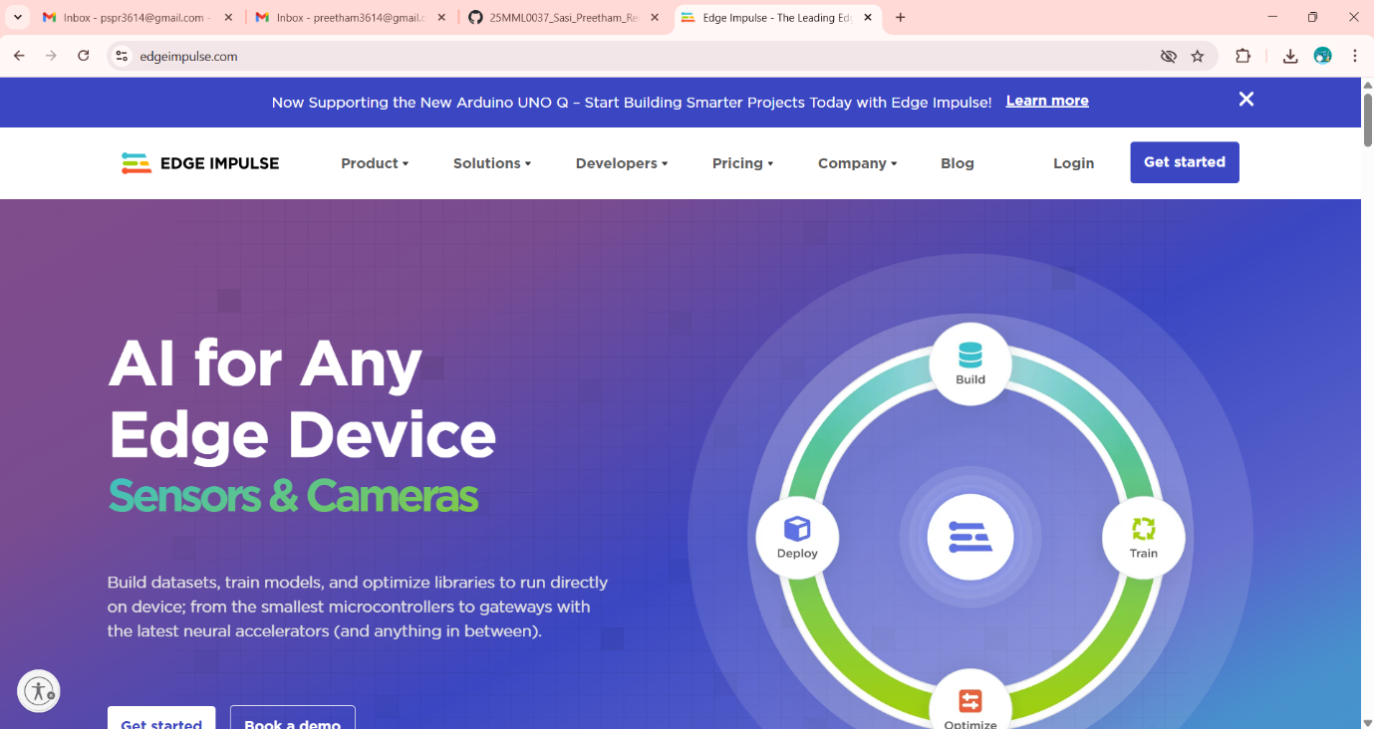

- Step 2 : Logging into Edge Impulse

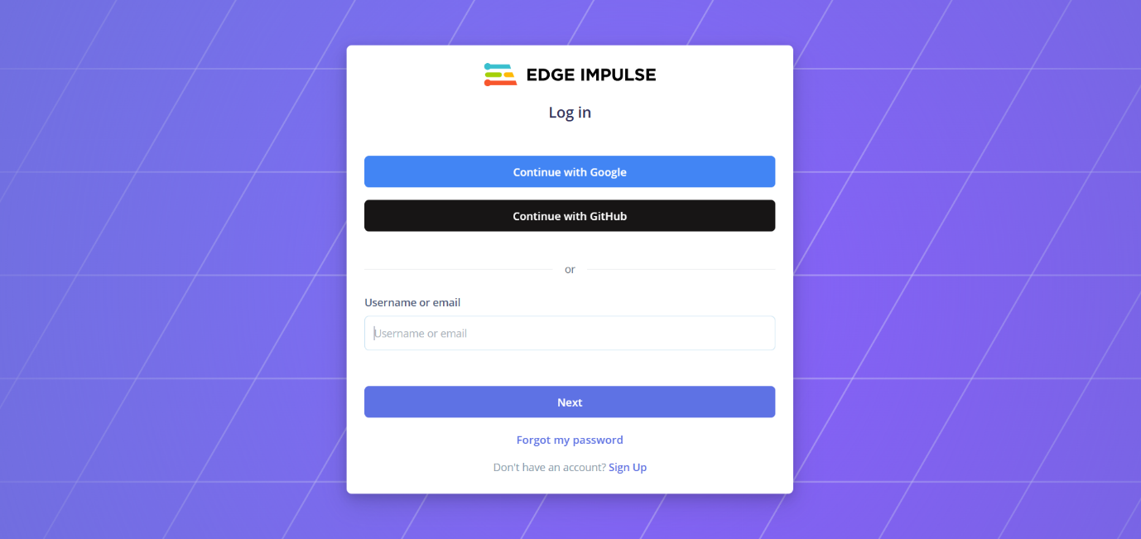
You can log in with either goolge or Github account. If you don’t have the account you can create the account by clicking signup button. After logging in open new project.
- Step 3 : Data Acquisition
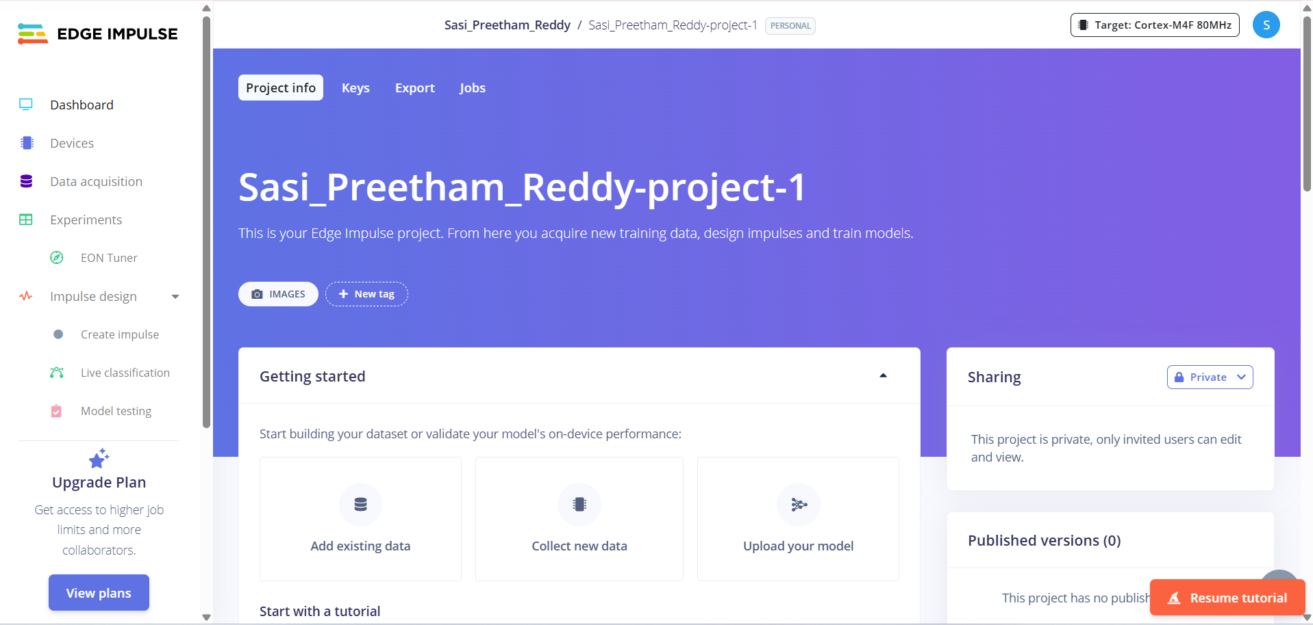

Click on the Data acquisition tab on the left side of the window

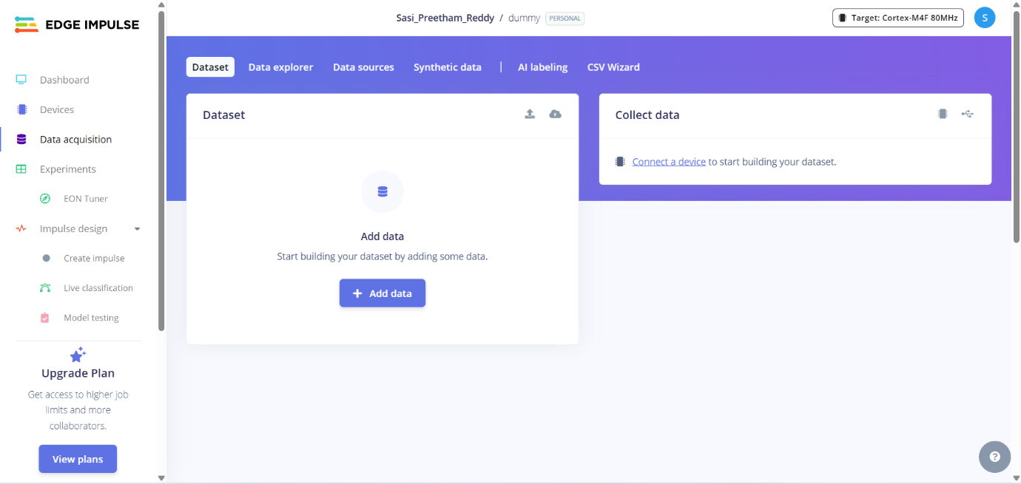

Now you can click on the connect to device to connect external device to collect the dataset from external devices
You can collect the data using 3 ways
- Connect to Mobile
- Connect to Computer
- Connect to development board

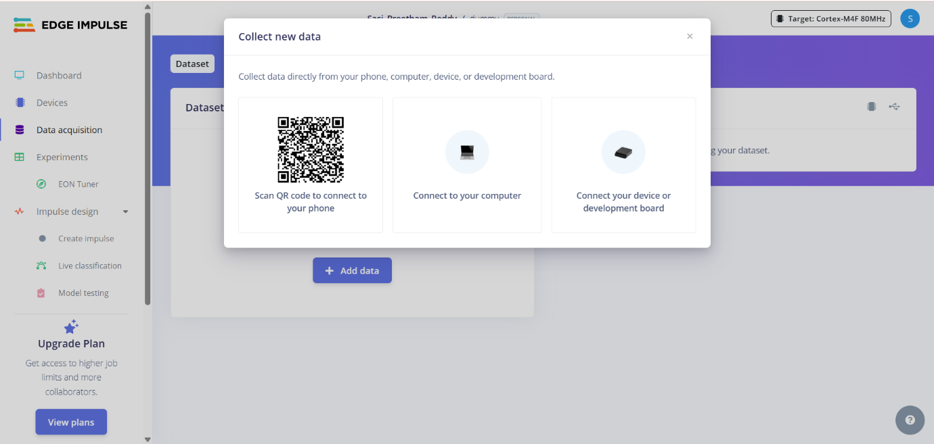

By scanning the QR code you can connect you mobile. And you can collect the data using the mobile
After collecting the data from the mobile it will look something like this

